Chapter 06 - Exploring the world
- What is a Microservice?
- A microservice is an independently deployable service that handles a single business capability and communicates with other services through APIs.
- A microservice is a small, independent, and self-contained service that performs one specific business function and communicates with other services over APIs (usually HTTP/REST or messaging).
- Instead of building one large application (a monolith), the application is broken into multiple small services, each responsible for a single capability.
- Microservices architecture is a way of building software where the application is divided into independent services, each developed, deployed, and scaled separately.
- Each service: Has its own codebase , Can be updated independently, Communicates via APIs.( REST APIs, GraphQL, Message queues (Kafka, RabbitMQ))
⭐ Key Characteristics of Microservices
- Single Responsibility: Each microservice does one job well.
- Independent Deployment: You can deploy one service without redeploying the whole app.
- Loosely Coupled: Services are connected via APIs, not tightly bound code.
- Own Database: Each microservice usually manages its own data.
- Technology Independent: Different services can use different technologies.
- Advantages of Microservices
✔ Faster development & deployment
✔ Better scalability
✔ Fault isolation
✔ Team autonomy
✔ Easier maintenance for large systems
- Challenges
❌ Complex infrastructure
❌ Network latency
❌ Data consistency
❌ Monitoring & debugging harder
- When to Use Microservices: Large applications, Multiple development teams, Need for high scalability, Frequent deployments

- What is Monolith architecture?
- It is a design where an application is built and deployed as a single, tightly coupled unit.
- All components—UI, business logic, and database access—are tightly coupled and deployed together as one application.
- A monolith is an application where all features and modules live in one codebase and run as one service.
- When to Use Monolithic Architecture: Small to medium applications, Single or small teams, Early-stage projects, Simple business logic.
⭐ Key Characteristics of Microservices
- Single Codebase: All functionality exists in one project.
- Single Deployment: Any change—small or large—requires redeploying the entire application.
- Tightly Coupled Components: Modules depend heavily on each other.
- Shared Database: All modules usually access the same database.
- Single Technology Stack: The whole app is built using one tech stack.

- Advantages of Microservices
✔ Simple to develop and test
✔ Easy deployment
✔ Lower infrastructure cost
✔ Easier debugging
- Challenges
❌ Hard to scale specific features
❌ Large codebase becomes difficult to maintain
❌ Any change requires full redeployment
❌ One bug can impact entire application

- What is the difference between Monolith and Microservice?
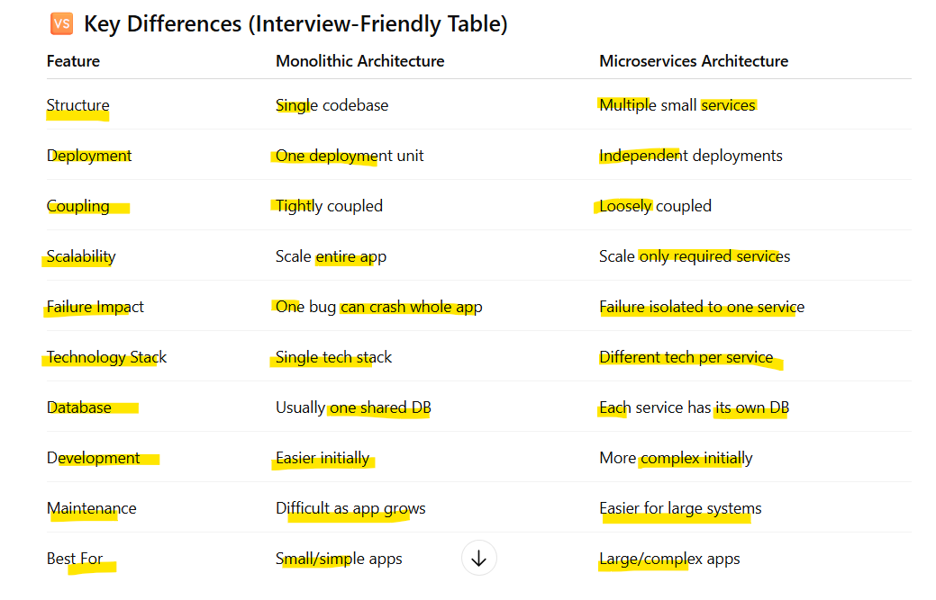

- Why do we need a useEffect Hook?
- useEffect allows you to perform side effects in functional components after the component renders.
- It lets React functional components perform side effects and handle lifecycle-related behavior such as API calls, subscriptions, timers, and DOM updates.
- Without useEffect, functional components would be unable to run code in response to component lifecycle events.
- What are Side Effects? Side effects are operations that:
- interact with external systems
- are not purely related to rendering UI
- useEffect is Needed:
- To Fetch Data: API calls should not be done during rendering.
- To React to State or Prop Changes: Run logic when specific values change.
- To Sync UI with External Systems: like Browser APIs, WebSockets, Local storage
- To Clean Up Resources: Prevents memory leaks.
- Key Rules of useEffect
  - Runs after render
  - Dependency array controls when it runs
  - Cleanup function runs before unmount or re-run
- What is Optional Chaining?
- JavaScript feature that lets you safely access deeply nested object properties, methods, or array elements without causing runtime errors if a value is null or undefined
- Optional chaining (?.) stops the execution and returns undefined if the value before it is null or undefined.
- How Optional Chaining Works:
- Checks the value before ?.
- If it's null or undefined → returns undefined Otherwise → continues accessing the property
- Common Use Cases:
  - Access Object Properties user?.profile?.email
  - Call Functions Safely user.logout?.();
  - Access Array Elements users?.[0]?.name
  - API Response Handling (Common in React) const city = response?.data?.user?.address?.city;
⚠️ Important Notes
- Only checks for null or undefined
- Does not catch other errors
- Cannot be used on the left-hand side of assignment user?.name = "John";

- What is Shimmer UI?
- Shimmer UI is a loading placeholder design pattern that shows animated skeleton screens while actual content is being fetched or processed.
- UI pattern that displays animated placeholder elements to indicate content is loading.
- Render skeleton components instead of real data and replace skeletons once data loads.
- Users understand the page structure and perceived loading time feels shorter and smoother UX
- Conditional Rendering
return isLoading ? <ShimmerCard /> : <RealContent />;

- What is the difference between JS expression and JS statement
- A JavaScript expression produces a value, while a JavaScript statement performs an action and does not return a value.
- JavaScript Expression: is any valid piece of code that produces a value. Expressions can be evaluated and return something.
- Always returns a value and Can be used inside JSX
  - Example
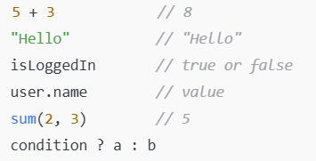

  - Expression in React JSX
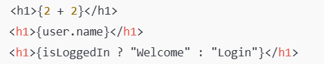
- JavaScript Statement: is an instruction that performs an action but does not return a value.
- Statements control program flow.
- Does not return a usable value and Cannot be used directly inside JSX
  - Example
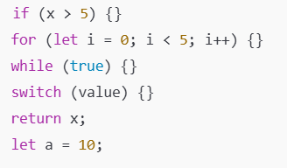
  - Invalid in JSX


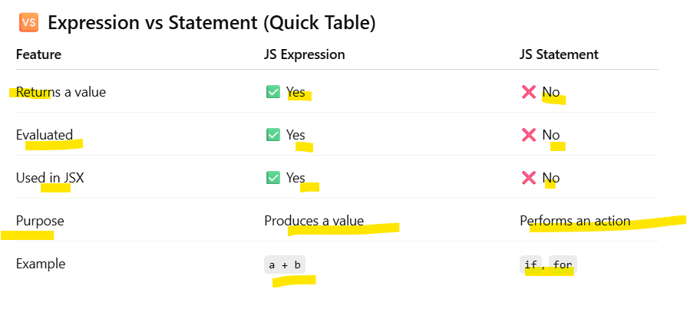
PS: JSX only allows expressions, not statements.
- What is Conditional Rendering, explain with a code example
Conditional Rendering means displaying different UI elements based on a condition (state, props, or any expression).
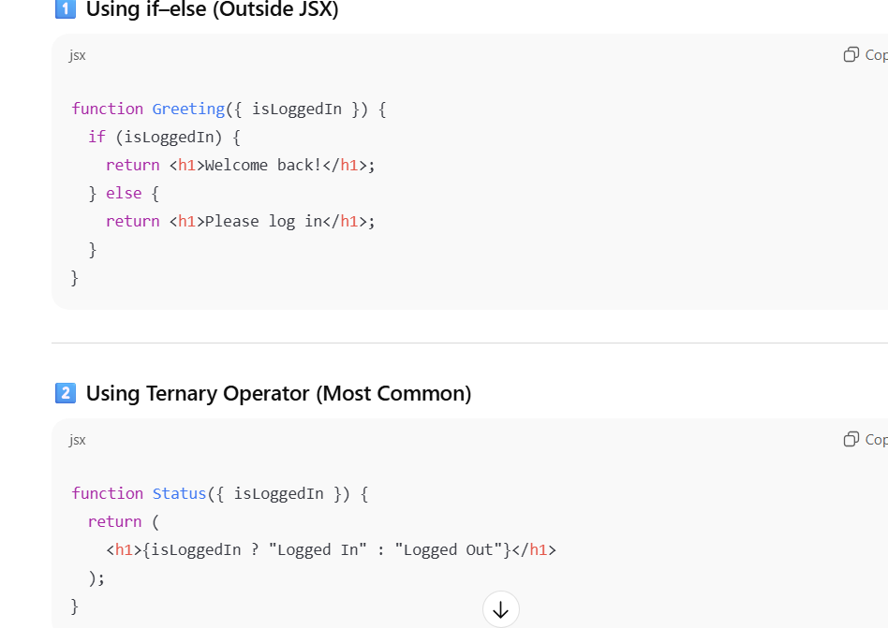
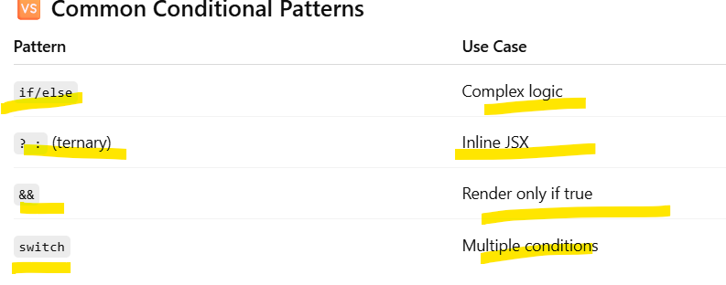

- What is CORS?
- CORS is a browser security mechanism that controls how web applications access resources from a different origin (domain, protocol, or port).
- CORS is a browser-enforced security policy that allows or blocks cross-origin HTTP requests based on server-defined rules.

- What is async and await?
- What is the use of `const json = await data.json();` in getRestaurants()
await data.json()
- Waits for the JSON parsing to complete
- Stores the parsed result in json
await data.json() extracts the JSON data from the HTTP response and converts it into a usable JavaScript object by parsing JSON asynchronously.
Why await is Needed: Both: fetch() and response.json() are asynchronous and return promises.
